**EZ English**

* Đề 1:

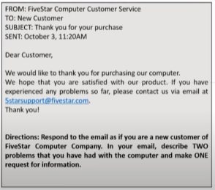

Answer:

Dear Sir or Madam,

My name is Rony and I’m writing in response to your email dated October 3rd about my recent purchase.

I purchased a new laptop computer from your company 1 month ago. At first, it worked fine but now I have many issues about the laptop computer. First, it takes a long time for the laptop computer to start up. Second, it cannot install any programs.

Could you please tell me how to fix these issues. I really need to install some programs for my job.

I’m looking forward to hearing from you.

Best regards,

Rony

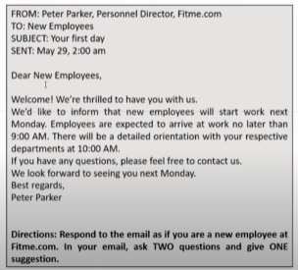

Answer:

Dear Mr.Parker,

My name is Rony and I work in Data Analyst Department. I’m writing in response to your email dated May 29th about my first day.

I have 2 questions about the company. First, I plan to go to work by my bicycle. Could you please tell where I can park my bike. Second, I would like to know what the **dress code** (quy định trang phục) is. This is because I saw some employees wearing casual clothes. Last, it would be a good idea to meet other new employees, so I suggest a welcome lunch for all new employees.

Thank you for reading my email.

Best regards,

Rony

* Đề 2:

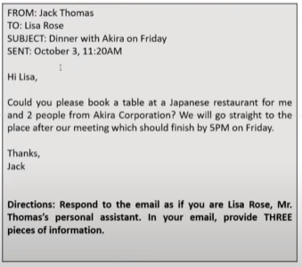

Answer:

Dear Mr. Thomas,

I’m writing in response to your email dated October 3rd about dinner with Akira on Friday.

I have booked a table for 3 people at Sumo restaurant. This restaurant is located at 22 Spring Street. In addition, the reservation is made under the name of Thomas.

If you need anything else, please let me know it. I’m looking forward to hearing from you.

Best regards,

Lisa Rose

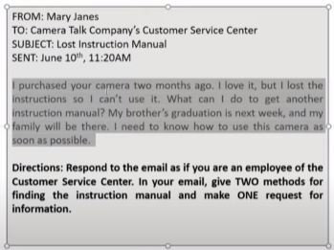

Dear Ms. Janes,

I’m Rony and I’m an employee at Camera Talk Company’s Customer Service Center. I’m writing in response to your email dated June 10th about your lost instruction manual.

There are 2 methods for you to get the instruction manual. First, you can download instantly the new instruction manual on our website. Alternatively, you can receive it from us by post. If you choose to receive the new instruction manual by post/ the latter, please let me know your address.

I’m looking forward to hearing from you.

Best regards,

Rony

* Đề 3:

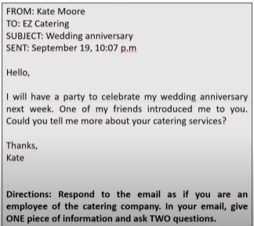

Answer:

Dear Ms. Moore,

Thank you for choosing our service. My name is Rony and I’m an employee at EZ Catering. I’m writing in response to your email dated September 19th about your wedding anniversary.

Currently, we are offering full service for all types of events. To know what you need, could you please tell me the number of guests? In addition, what is your budget for this party.

I’m looking forward to hearing from you.

Best regards,

Rony

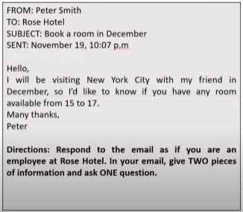

Answer:

Dear Mr. Smith,

Thank you for choosing our hotel. My name is Rony and I’m an employee at Rose Hotel. I’m writing in response to your email dated November 19th about book a room in December.

Currently, our hotel have two room available from December 15th to December 17th at 9AM. The fee is $200/room. If you want to rent, could you please give me some information about you such as your phone number and your time when you arrive.

I’m looking forward to hearing from you.

Best regards,

Rony

**Phạm Hương Liên TOEIC**

* Đề 1:

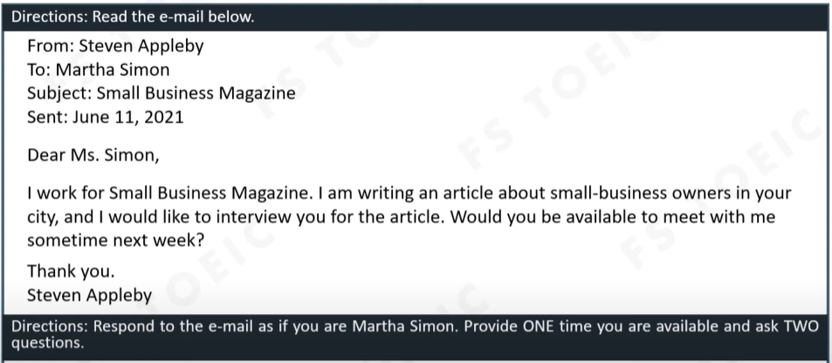

Answer:

Dear Mr. Appleby,

I’m writing in response to your email dated June 11th about your small business magazine. Thank you for contact with me.

I would available to meet you on Monday next week at 6PM. I have some questions for you about the meeting. First, why do you want to contact with me? Second, how many questions do you want to ask me? This is because I want to prepare well for the meeting.

I’m looking forward to hearing from you.

Best regards,

Martha Simon

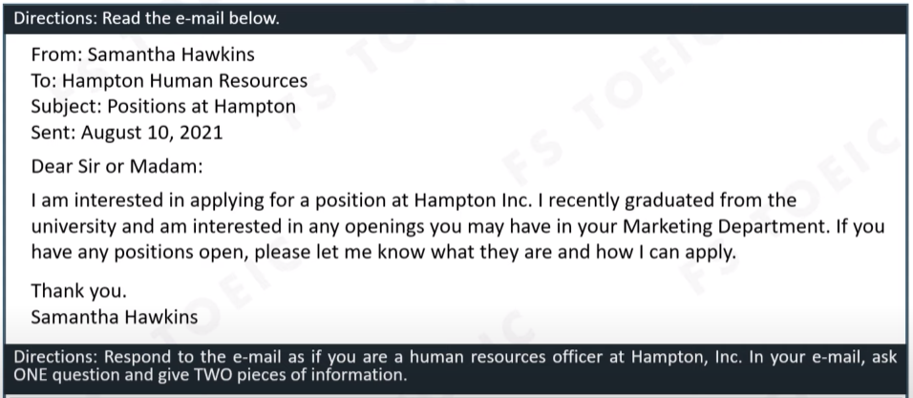

Answer:

Dear Ms. Hawkins,

Thank you for applying a position at Hampton Inc. My name is Rony and I’m a person of Hampton Human Resources. I’m writing in response to your email dated August 10th about your apply positions at Hampton.

I have one question for you. There are many companies outside so why do you choose Hampton Inc to work? We have vacant positions at Marketing Social Media and Marketing Analyst. If you want to apply at these postions, you need to have these things. First, you need to have knowledge about analyst and have experience in writing. Second, you need to know how to use some programs such as Canva, Adobe Photoshop.

I hope you have all things that we need.

Best regards,

Rony

* Đề 2:

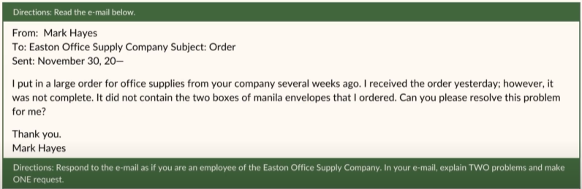

Answer:

Dear Mr.Hayes,

Thank you for choosing our service. My name is Rony and I’m an employee at Easton Office Supply. I’m writing in response to your email dated November 30th about your orders. I’m so sorry about that issues.

You did not receive the two boxes of manila envelopes because the shipper was forgotten to check your orders. And one thing, maybe the address on these boxes was be deleted when shipping. I’m so sorry to hear about that so could you please tell me your ID of your orders, I will check and give it back to you soon.

I’m looking forward to hearing from you.

Best regards,

Rony

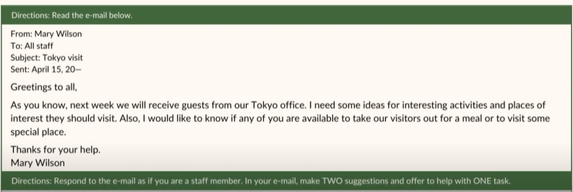

Answer:

Dear Ms. Wilson,

My name is Rony and I’m an employee in Data Analyst Department. I’m writing in response to your email dated April 15th about tokyo visit.

I could available to take our visitors out for a meal or to visit some special place. First, I suggest we should take our visitors go to Sumo restaurant to eat some special food in here. Second, I suggest we should take them go to Daichi beach. This is because the beach here very beautiful. Last, could you please help me to take them to Sumo restaurant, I will be get there when I finish my job?

I’m looking forward to hearing from you.

Best regards,

Rony

* Đề 3:

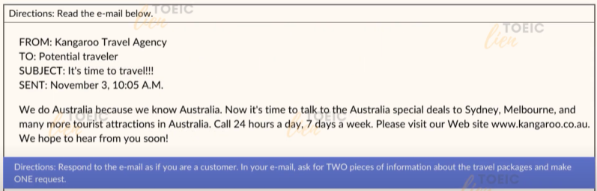

Answer:

Dear Sir or Madam,

My name is Rony and I’m writing in response to your email dated November 3rd about travel to Australia.

I have some questions about your service to travel to Australia. First, could you please tell me what cost for one person travel to Australia is? In addition, could you please tell me where we will go in your travel packages? I would like to ride a bike, so can you rent me a bike?

I’m looking forward to hearing from you.

Best regards,

Rony

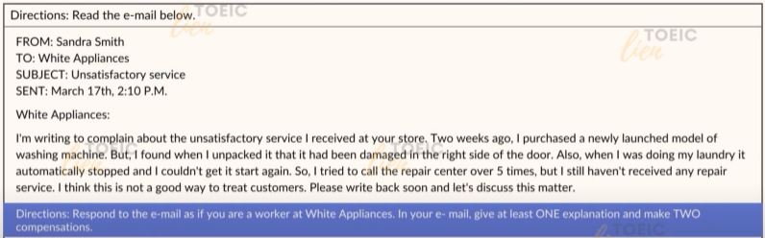

Answer:

Dear Ms. Smith,

My name is Rony and I’m a worker at White Appliances. I’m writing in response to your email dated March 17th about your unsatisfactory service.

I’m so sorry about that your washing machine had been damged before using. Maybe the shipper wasn’t careful when shipping. Would you mind if I take it back and give you another washing machine as you purchased. In addition, I hear that you tried to call the repair center over 5 times. I’m sorry about that, this is because the repair center was being updated. I will give some employee to fix your laundry so could you please give me your address?

I’m looking forward to hearing from you.

Best regards,

Rony

* Đề 4:

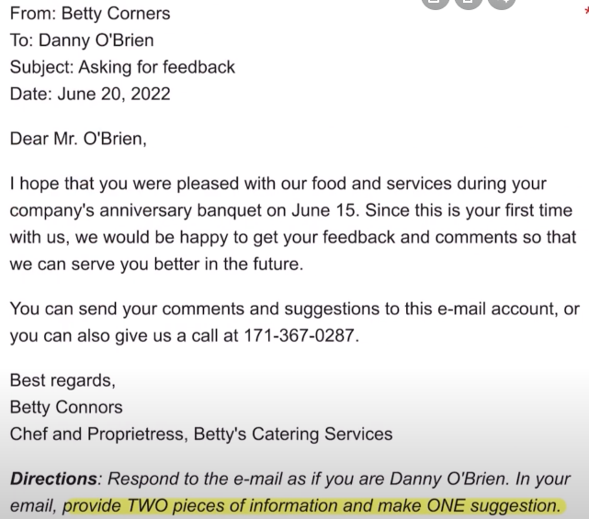

Answer:

Dear Ms. Corners,

I’m writing in response to your email dated June 20 about asking for feedback. I’m very pleased with your food and your services.

First, the salmon was too salt so I feel uncomfortable. So next time, can you decrease the salt into the salmon. In addition, your mushroom soup was very delicous. I cannot stop to eat so I want to eat more and more after.

Thank you so much for your food.

Best regards,

Danny O’Brien

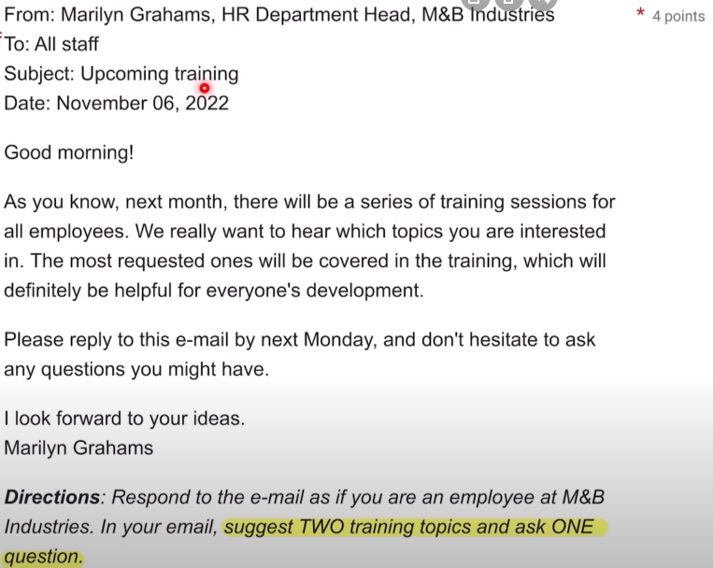

Answer:

Dear Ms. Grahams,

My name is Rony and I am an employee at Data Analyst Department. I am writing in response to your email dated November 6th about upcoming training.

I am interested in swimming skills and medical skills. First, I suggest we should have some days for our employees to training swimming in the pool. In addition, I suggest we should have some days for medical skills. This is because I really helpful in our life. Last, I have got one question what is the exact day that we begin to training sessions for all employees?

I am looking forward to hearing from you.

Best regards,

Rony